

Process to Set Up, Change or Reset Your Password to Sigma Connect
In the past, we have set up generic passwords for our members to log into Sigma Connect. However, due to increased password issues/violations connecting to Sigma Connect, we have changed the password for logging into Sigma Connect. Each member must have its own unique password and should not share this password with any other member. Your email address also allows you to gain access to the Billhighway accounting system.
- When logging into Sigma Connect you will be required to enter a password. When resetting your password, click on “Click here to set up your password, change your password, or to reset your password if it is forgotten. An email will also be sent confirming your log on number”. See Red arrow below.
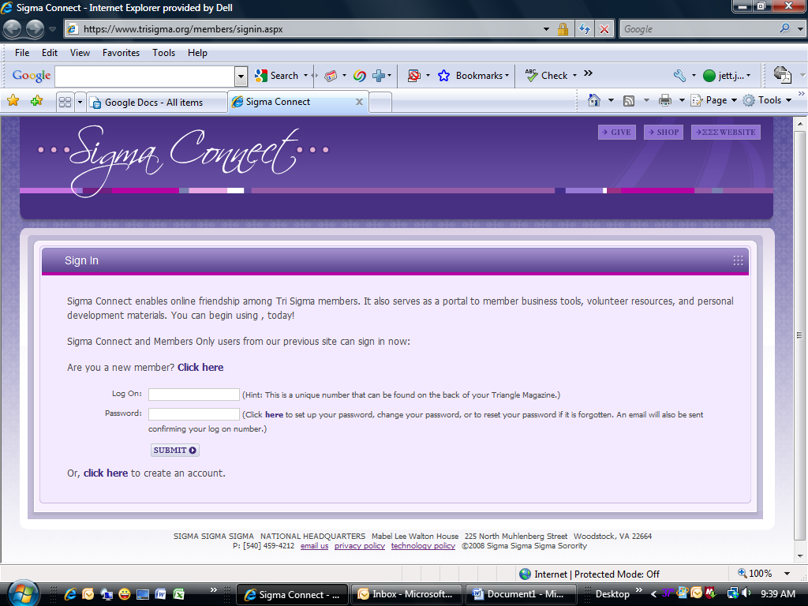


- Next you will be required to enter your email address; this is the email you placed on your M476 card.
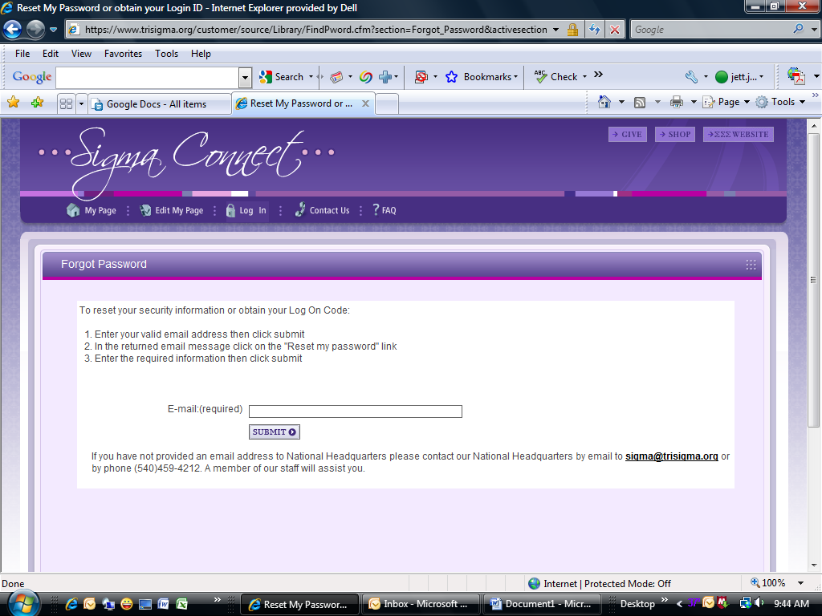

- Enter your email address and you will see a pop up box that says “An email containing a link that will allow you to reset your password will be sent momentarily.” If you do not use the email address on your M-476 card, you will not receive the link to reset your password. If you have difficulty remembering which email address you placed on your M476 card, contact your Vice President to identify which email address was used.
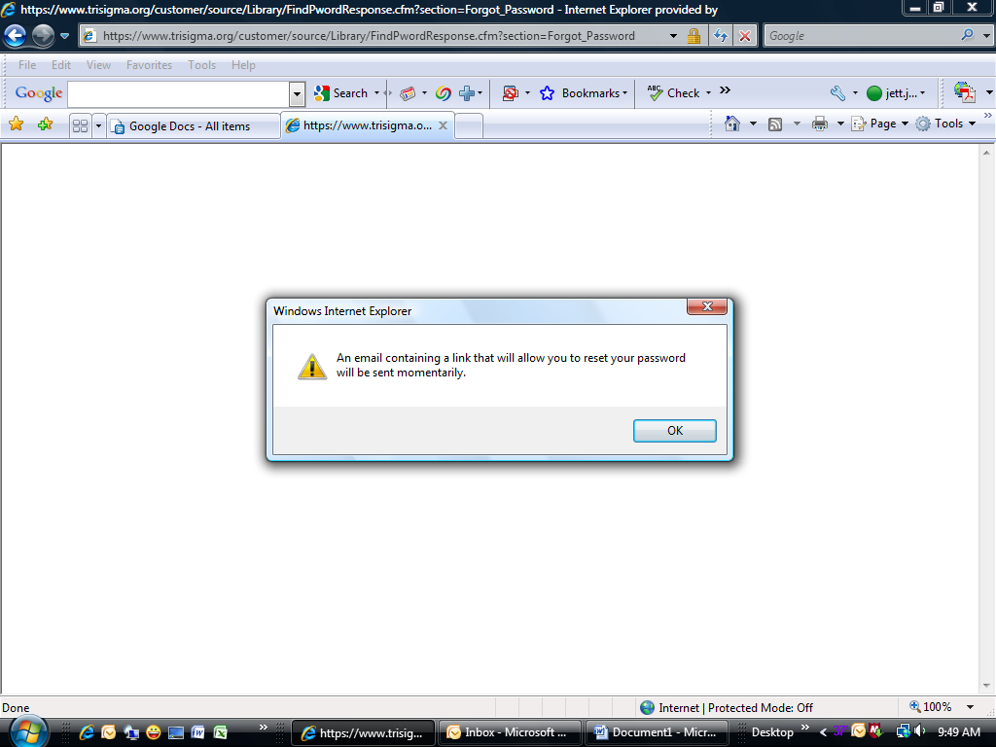

- You will receive an email with the following message:
Thank you for using Sigma Connect your Log On Code is: XXXXXX
Please click on the link below to create a new password for your account.
Note: If your e-mail program does not accept HTML, cut and paste the link into your web browser.
Reset my password
- Once you click on the “Reset my password” you will see the following screen:
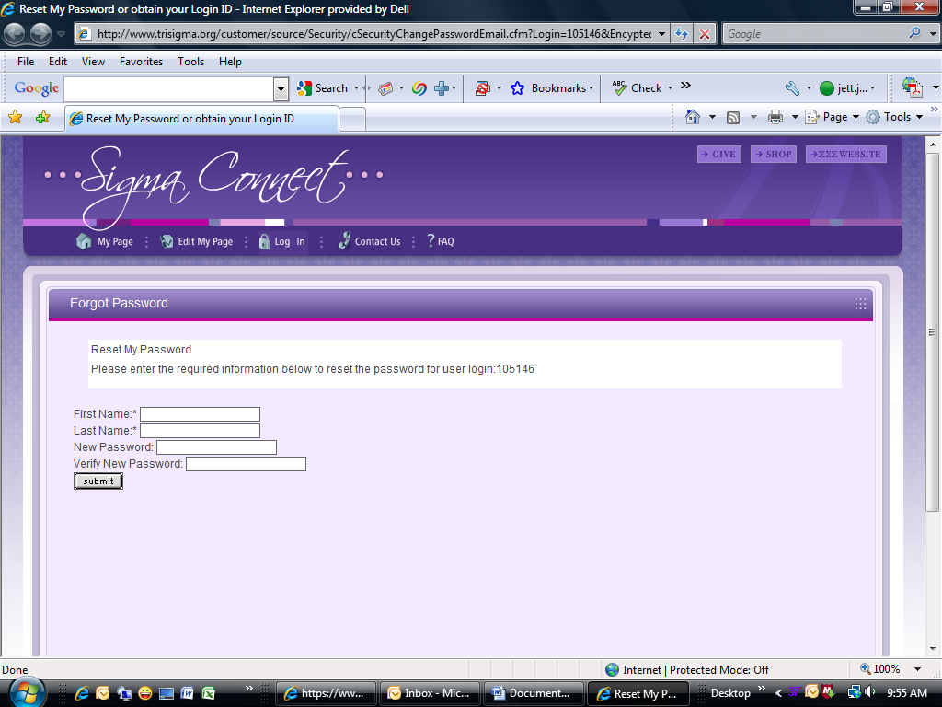
- Enter your first name, last name, new Password (using letter or numbers only - no special characters, no apostrophes, no hyphens), verify new Password and click submit. Once you have done this you will be able to log on to Sigma Connect with your new password.
If you have any additional problems, please contact National Headquarters at 540-459-4212 or email your issue to sigma@trisigma.org . As a reminder, the sharing of passwords is prohibited.

